REPORT ON TITANIC DATASET

The Titanic Dataset shows the relationship between different categories of people that embarked on a Journey to use the Titanic ship. The Dataset gives information about the people that survived and those that did not survive and also shows the different age and classes of people that embarked on the journey.

Moreover, this dataset consists of 1309 rows and 13 columns

Below is the first five rows and columns

|  | **Unnamed: 0** | **PassengerId** | **Survived** | **Pclass** | **Name** | **Sex** | **Age** | **SibSp** | **Parch** | **Ticket** | **Fare** | **Cabin** | **Embarked** |
| --- | --- | --- | --- | --- | --- | --- | --- | --- | --- | --- | --- | --- | --- |
| **0** | 0 | 1 | 0 | 3 | Braund, Mr. Owen Harris | male | 22.0 | 1 | 0 | A/5 21171 | 7.2500 | NaN | S |
| **1** | 1 | 2 | 1 | 1 | Cumings, Mrs. John Bradley (Florence Briggs Th... | female | 38.0 | 1 | 0 | PC 17599 | 71.2833 | C85 | C |
| **2** | 2 | 3 | 1 | 3 | Heikkinen, Miss. Laina | female | 26.0 | 0 | 0 | STON/O2. 3101282 | 7.9250 | NaN | S |
| **3** | 3 | 4 | 1 | 1 | Futrelle, Mrs. Jacques Heath (Lily May Peel) | female | 35.0 | 1 | 0 | 113803 | 53.1000 | C123 | S |
| **4** | 4 | 5 | 0 | 3 | Allen, Mr. William Henry | male | 35.0 | 0 | 0 | 373450 | 8.0500 | NaN | S |

SURVIVAL BY AGE

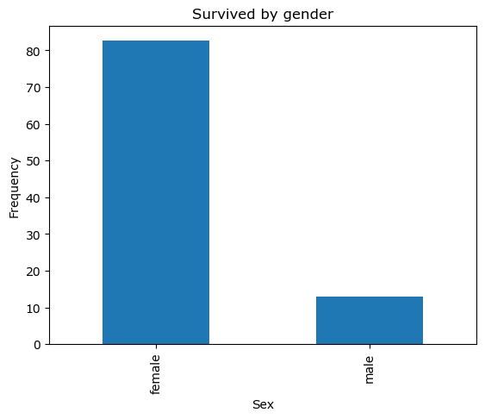

From the survived by gender visualization, female ranging from 0 to 80 survived and male ranging from 0-10 survived . The rest did not survive .

SURVIVED RATE BY CLASS

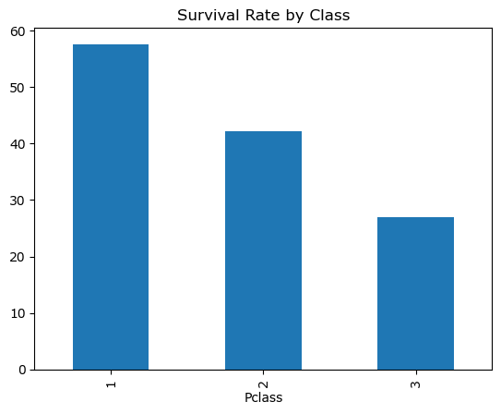

This plot explains that comparing survival in respect to Class, In Class 1, people ranging from 0 to 58 survived, In Class 2, people ranging from 0 to 42 survived and in Class 3, people ranging from 0 to 28 survived. The rest did not survive.

AGE DISTRIBUTION

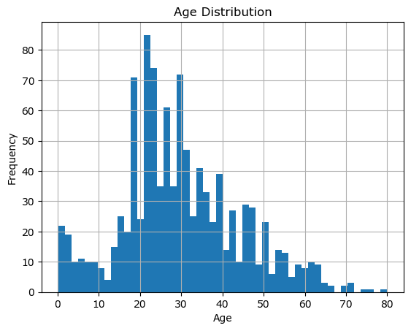

The Age Distribution shows that the maximum age we had in the ship is between the age of 22 to 24 and the minimum is between the age of 78 to 80

AGE DISTRIBUTION BY CLASS

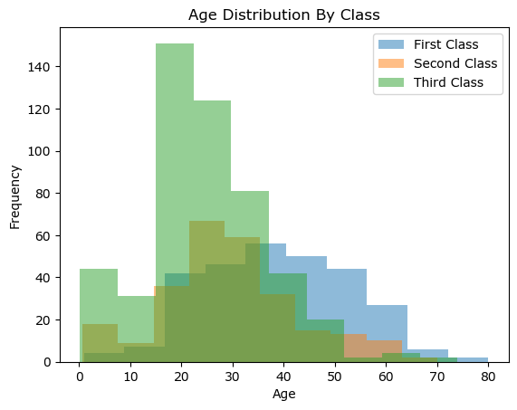

This Age Distribution by Class shows the number of people within a particular age that were in each classes. The people in First Class ranges within the age of 0 to 80, The people in Second Class ranges within the age of 0 to 70, The people in Third Class ranges within the range of 0 to 74.

FARE DISTRIBUTION

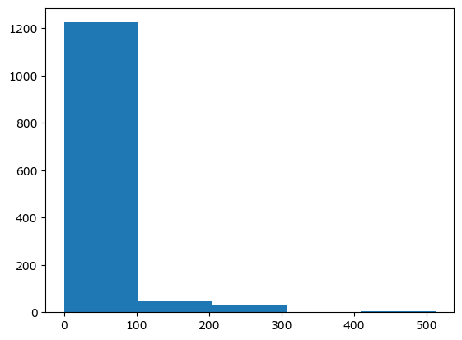

This is a Chart showing Fare Distribution, the maximum Fare Distribution is 1200 and the Minimum is 10

FARE DISTRIBUTION BY CLASS

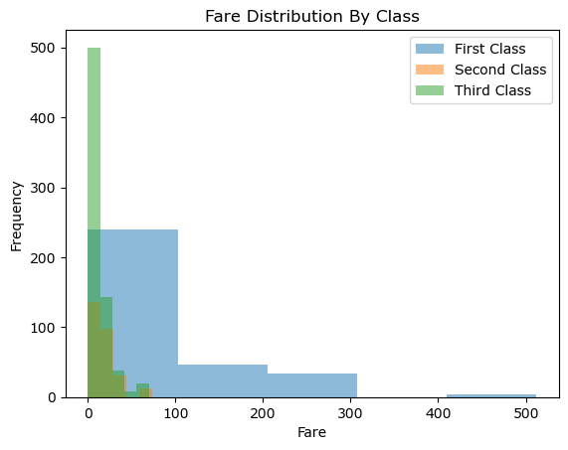

This is a Fare Distribution by Class. This describes the cost of transportation each person spent in different classes. First class spent from 0-301, Second Class spent from 0 to 97 and Third Class spent from 0-78.

DISTRIBUTION OF PASSENGERS &EMBARKED

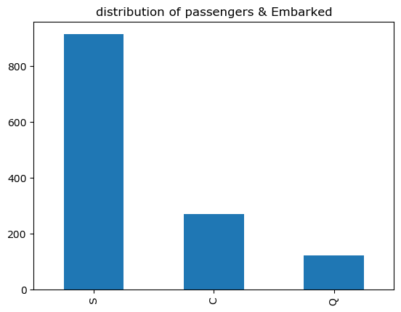

This is the distribution of passengers and those that embarked on the journey from different countries. The countries include; Southampton(C), Cherbourg(C), Queenstown(Q). The people from Southampton were 900, the people from Cherbourg were 280, the people from QueensTown were 180. Therefore, Southampton had the maximum number of Passengers that embarked on the journey and The people from QueensTown that embarked on the journey was the minimum.

SURVIVAL RATE BY CABIN CLASS

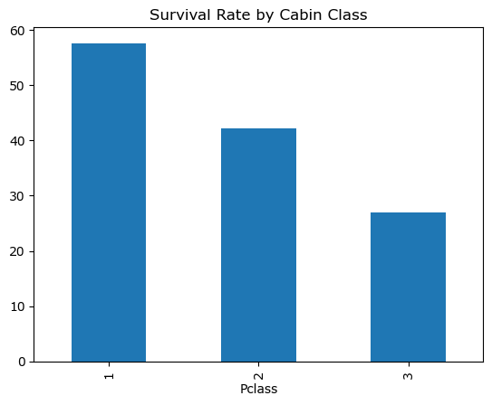

This shows people in Pclass that survived.

In Pclass 1- 58 survived , Pclass 2 - 42 survived and in Pclass 3 - 27 survived.

HEAT MAP

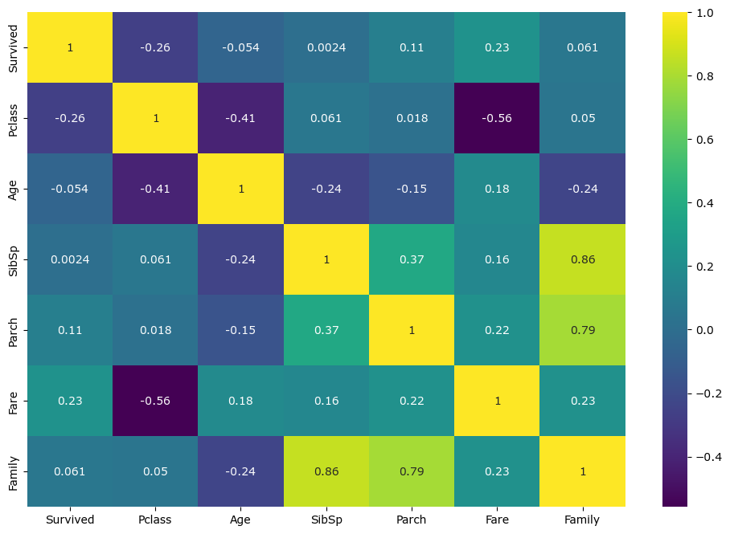

The heat map shows that correlation between different variables which includes; Survived, Pclass, Age, SibSp, Parch, Fare, Family.

Family, Fare and Parch has the strongest relationship and Pclass has the Weakest correlation.

CONCLUSION

The Titanic Dataset gives a proper information about the relationship between different variables. It shows the number of People in different classes and age that survived in the Titanic ship and the number of persons the did not survive.